Quiz Unit 1

What is python?

Define interpreter?

Write down what you would expect to get back from the terminal (string, an integer, a float, or an error). If it’s an error message, describe why.

1. 2 \* 4 \* .5
2. 3 // 2
3. x
4. ‘ab’
5. ‘ab + b’
6. ‘ab’ + ‘b’
7. ‘1’ \* ‘b’
8. ‘a’ \* 2

What will be printed out after this code:

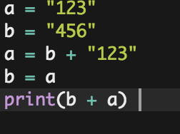

Write out a program that asks the users name, and returns a personalized greeting to them.